Essex County Council has today revealed the map of how three brand-new unitary councils could replace the 15 current local authorities across Greater Essex.
The new councils would mean the abolition of all the existing councils, including the existing unitaries of Thurrock and Southend on Sea, as well as all the councils in the county council area. The map, published today, reveals a configuration based on:
- South Essex Unitary: Southend, Rochford, Castle Point, Basildon, Thurrock
- Central Essex Unitary: Chelmsford, Brentwood, Epping Forest, Harlow, Maldon
- North Essex Unitary: Colchester, Tendring, Braintree, Uttlesford
Each new council would take full control of local services – from schools and roads, to social care and bin collections – in a move designed to simplify governance, save money and deliver better outcomes for residents.
The plan puts Essex's three cities – Southend-on-Sea, Chelmsford and Colchester – at the heart of each new authority, in order to power economic growth, create thriving communities, and provide excellent services.
The recommendation follows months of detailed analysis, with the council working alongside partners to explore multiple options. The proposal, which will be published in full later this summer, is based on evidence, financial modelling and the Government's criteria for Local Government Reorganisation (LGR).
The county council's Leader, Councillor Kevin Bentley, believes the configuration strikes the right balance between urban and rural needs, keeps economically-linked areas together and would offer financial stability, avoiding major funding gaps between essential services and demand.
Councillor Bentley said: "We've painstakingly weighed up the options and have concluded this model delivers the best possible value and outcomes for Essex.
"Three councils offers the simplicity, strength, and stability our great county is crying out for and which the status quo does not offer. It is also 100% based on solid evidence. If Greater Essex is to achieve its full potential, and be a place where communities and the economy can thrive, I firmly believe it is the best available option."
The recommendation will now be included in a formal business case which will be submitted to government by 26 September.
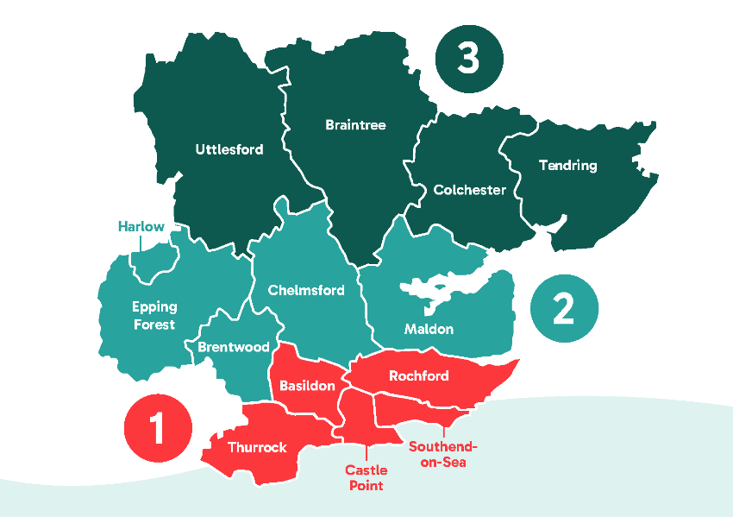
Alongside this three-council proposal, Southend-on-Sea City Council is leading work on business case for five councils, while Thurrock Council is intending to develop a business case based on a four. The Government will consider all proposals before deciding which business cases will go forward to public consultation.
A map of the proposed three unitaries in Greater Essex

Cllr Peter Schwier AIEMA
Cabinet Member for Environment, Waste Reduction & Recycling
Chair, East of England Regional Climate Change Forum

Hedingham Division, Essex County Council
Renewal, Equality & Ambition

