**District Councillor's Report to Parish Councils July 2025**

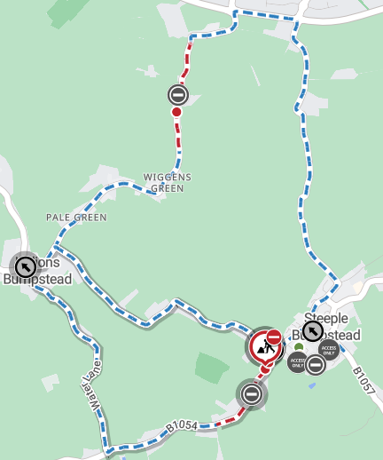**Cllr. Diana Garrod - Bumpstead Ward**

**Scheduled Temporary Traffic Regulation Orders & Roadworks**

Multi-way traffic signal at New England, Sturmer Road. Commenced 1st May to 24th October 2025 for Utility Asset Works. Anglian Water. Project: SEW-12079 - Stambourne Pump Away Scheme. Installing underground storm water storage pipes. E: **onealliancecustomers@anglianwater.co.uk** T: **03457 145 145**.

Intended closure of Water Lane, Hempstead Road, due to commence on 23rd July 2025 for 30 days. The closure is required while ECC undertakes surfacing. Info: [https://one.network/?tm=142991133](https://gbr01.safelinks.protection.outlook.com/?url=https%3A%2F%2Fone.network%2F%3Ftm%3D142991133&data=05%7C02%7Ccllr.dgarrod%40braintree.gov.uk%7C6289afd3b136451f43c108ddb5514fda%7C25f7dc6a2f004c05bf5b651e113d3f16%7C0%7C0%7C638866083041247576%7CUnknown%7CTWFpbGZsb3d8eyJFbXB0eU1hcGkiOnRydWUsIlYiOiIwLjAuMDAwMCIsIlAiOiJXaW4zMiIsIkFOIjoiTWFpbCIsIldUIjoyfQ%3D%3D%7C0%7C%7C%7C&sdata=orNCoj0LOAPOtYwn6ZLHKYvAU8K44%2B75in8ZPRIhb30%3D&reserved=0)

**Colne Valley Arms – New England**

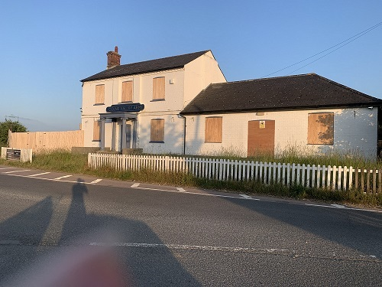I received an enquiry about the Colne Valley Arms (formerly The Tavern) at New England, which has been boarded up for some time now. It is an eyesore on the A1017. There has been tentative enquiries made with BDC to consider potential options. However, BDC has advised that it should be marketed for an alternative use before any potential residential development could be considered. If they were looking at another commercial use, they would need to demonstrate that the public house is no longer viable.

**Bottle Banks**

I received an enquiry as to the proposals for bottle banks when the new waste services are introduced in June 2026 and received the following reply from officers at BDC:-

‘*Bring banks will not be removed immediately as 12% of residents who responded to the consultation stated they would continue to use them. Instead, their use will be reviewed which may lead to the space being used to collect other materials such as small electrical items’*.

**Greater Anglia to be Nationalised**

It has been confirmed by the Department for Transport that Greater Anglia is scheduled to become a publicly owned railway on 12 October 2025. With the railway network facilitating 82 million passenger journeys in 2024/25, Greater Anglia have promised to prioritise a smooth transition, with no planned change to train service operations or employee roles.

**Essex Devolution**

Ten out of 15 council leaders in Essex have supported having 5 unitary councils in the county as part of LGR (Local Government Reorganisation) plans, a change from the current two-tier system containing a total of 15 district, unitary and county councils in the area. The plan includes Southend-on-Sea, Castle Point and Rochford working together to provide all local services, such as bin collections, social care, and highways, as one authority.

**Local Plan Sub-Committee Meetings – Sites in the Bumpstead Ward**

The Government’s mandatory housing target means BDC must allocate land to deliver 1,115 new homes a year for the district from 2033 to 2041. Meetings have been held during June 2025 to decide on the smaller sites which should be included into the Local Plan Review. The larger sites, e.g. STUR2293, a 314 hectare site, which straddles Sturmer and Helions Bumpstead, will be decided at a meeting either 24th September or 1st October 2025. Members of the public will be able to view and listen to the meeting via YouTube at the following link: <http://www.braintree.gov.uk/youtube>

Whilst the minutes for the following meetings are not all published, I can advise that the LPSC agreed with the recommendations set out in the agendas 12th, 19th and 25th June 2025, for those sites in the Bumpstead Ward which had been submitted:-

**Birdbrook, Baythorne End and New England: LPSC agenda for meeting held 12th June 2025**

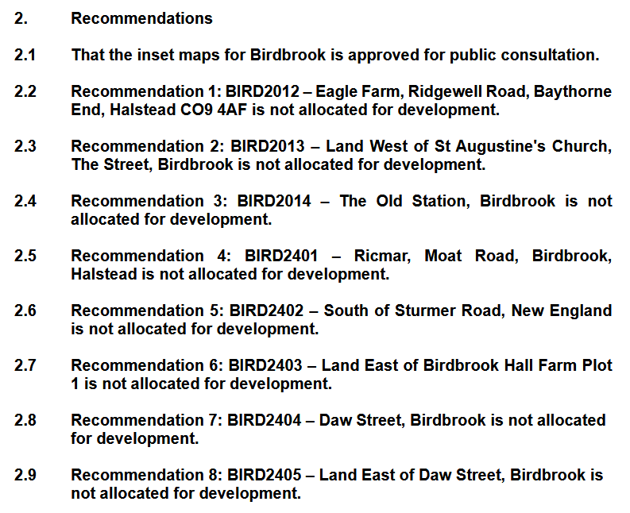

**Helions Bumpstead: LPSC agenda for meeting held 19th June 2025**

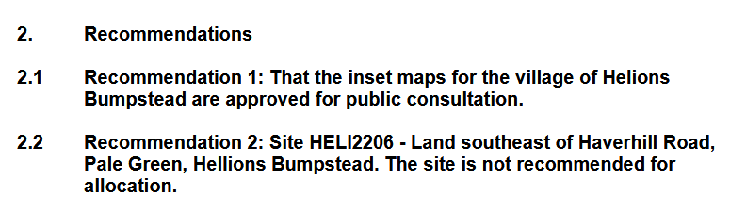

**Steeple Bumpstead: LPSC agenda for meeting held 25th June 2025**

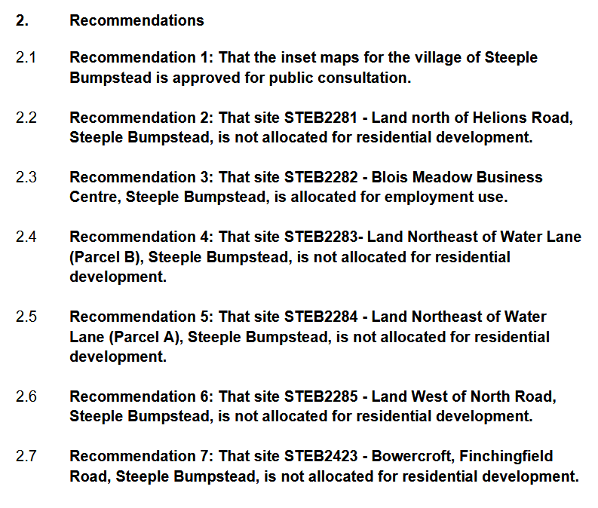



**Sturmer: LPSC agenda for meeting held 25th June 2025**

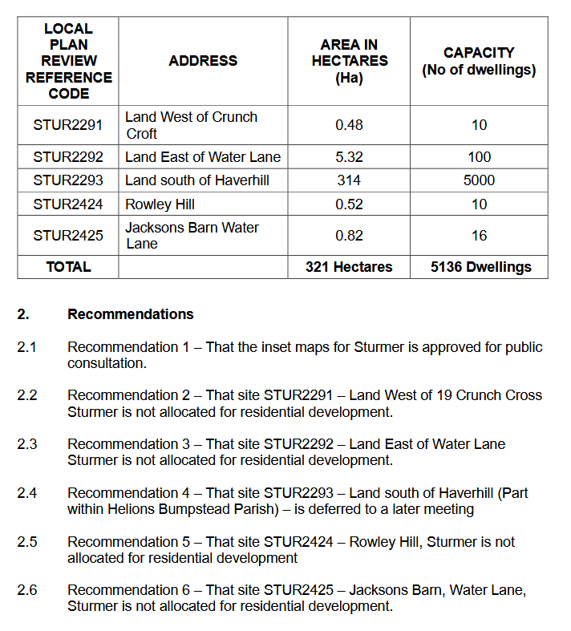



*Sturmer continued ….*



**Rural Prosperity Fund £176k – Now Open**

BDC is set to Allocate £176k to Businesses & Community Groups in Rural Areas

Grants between £2,000 and £20,000 are available for the execution of capital projects in rural areas. The grants could be used to:

* improve community facilities and infrastructure, such as village halls and churches
* create and improve green spaces
* boost access to arts, leisure and culture in a bid to grow local tourism economies
* support agricultural businesses looking to diversify or expand their remit
* help rural businesses looking to launch or grow their products and services

The initiative is open to small and micro businesses, parish councils, charities and community groups within rural areas and communities. The scheme requires applicants to match some of the funds for their projects.

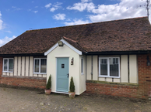

More information: <https://www.braintree.gov.uk/ruralprosperityfund>

*Last year, Finchingfield Holiday Cottages repaired and renovated an under used cottage adding an additional let to the family business thanks to the allocation of £19,608 from the UK Government’s Rural England Prosperity Fund.*

**Police News**

This weeks’ Crime Report indicates that a scaffolding tower was removed from outside a property in Camps Road CB9 7 (Bumpstead Ward) on 24th June 2025 at around 10:30.

Braintree PFCC Public Meeting is scheduled for Tuesday 8th July, 7-8pm, Braintree Town Hall, Market Place, Braintree, CM73YG. This is an opportunity to put questions to the Commissioner / Police.

The neighbourhood Policing team were in Witham to assist in the deployment of the Live Facial Recognition (LFR) vans in the town centre. During the Deployment there were 4 positive matches including 1 arrest and 1 breaching bail conditions.

**Cllr**. Diana Garrod

Braintree District Councillor - Bumpstead Ward