**District Councillor's Report to Sturmer Parish Council – 2nd meeting in June 2025 (26/06/25)**

**Cllr. Diana Garrod - Bumpstead Ward**

**Scheduled Temporary Traffic Regulation Orders & Roadworks**

Multi-way traffic signal at New England, Sturmer Road. Commenced 1st May to 24th October 2025 for Utility Asset Works. Anglian Water. Project: SEW-12079 - Stambourne Pump Away Scheme. Installing underground storm water storage pipes. E: **onealliancecustomers@anglianwater.co.uk** T: **03457 145 145**.

**Local Plan Sub-Committee Meetings – Sites in the Bumpstead Ward**

Local Plan Review to 2041. Meetings have been held during June to decide on the smaller sites which should be included into the Local Plan Review.  Minutes are not yet published. However, the agendas state the following:-

**Birdbrook, Baythorne End and New England: LPSC agenda for meeting held 12th June 2025**

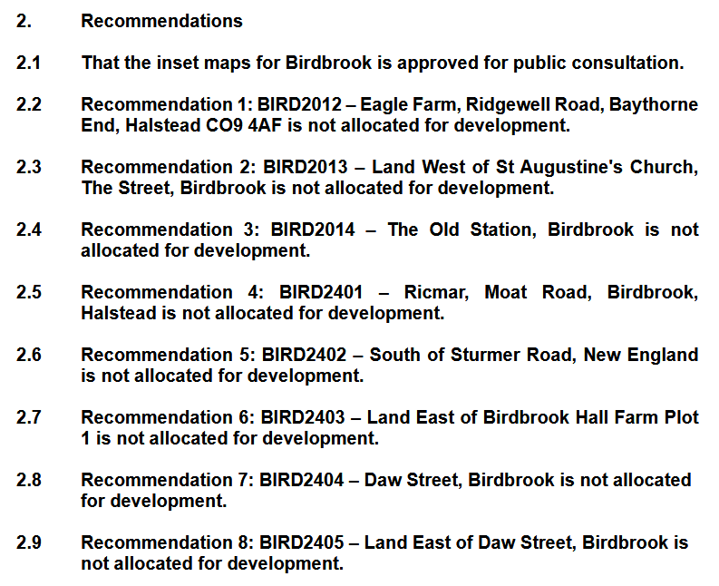

**Helions Bumpstead: LPSC agenda for meeting held 19th June 2025**

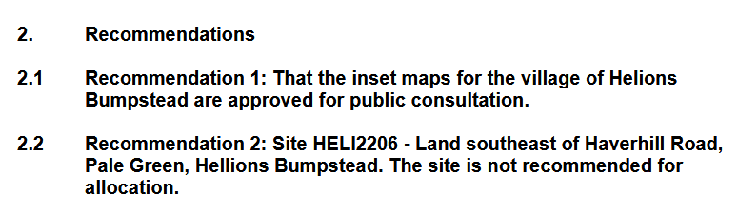

**Steeple Bumpstead: LPSC agenda for meeting held 25th June 2025**

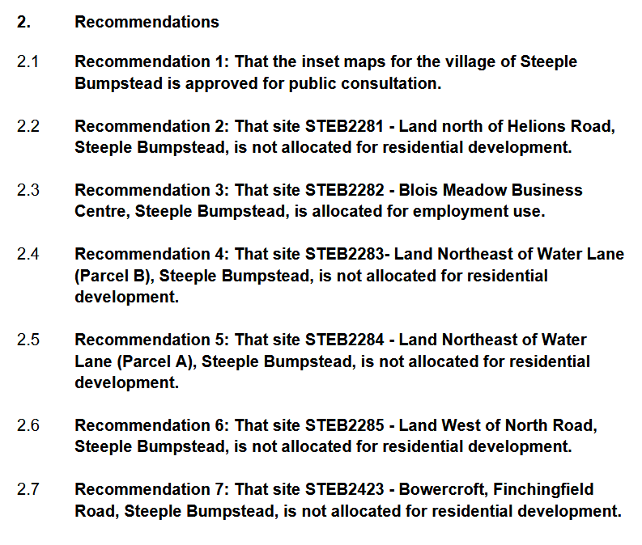

**Sturmer: LPSC agenda for meeting held 25th June 2025**

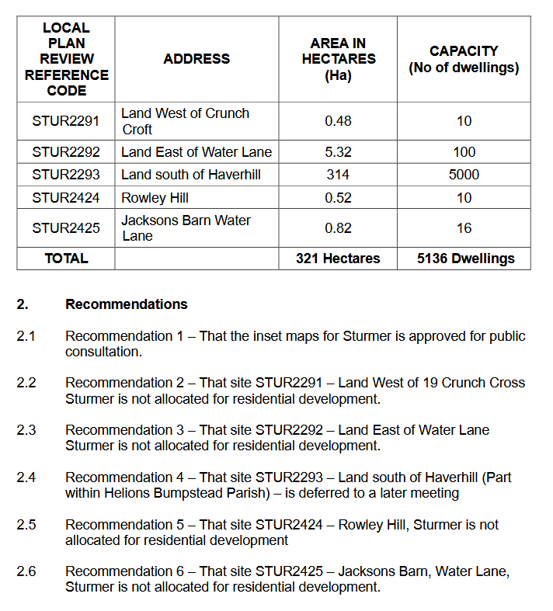

**I attended the meeting held 25th June 2025. There was one speaker from Steeple Bumpstead who commented on the sites. There were no speakers from Sturmer. All small Sturmer sites put forward (excl. site STUR 2293) were not allocated for development.**

**Cllr**. Diana Garrod

Braintree District Councillor - Bumpstead Ward