**District Councillor's Report to Parish Councils April 2025**

**Cllr. Diana Garrod - Bumpstead Ward**

**Scheduled Temporary Traffic Regulation Orders & Roadworks**

Multi-way signal traffic control at Four Ash Hill, Birdbrook 14th to 25th April 2025 for highway maintenance.

Ref: EP02263439592-02 More info at: <https://one.network/>

**Waste Consultation Update**

The Government policy says ‘*Simpler Recycling will enable consistent, more streamlined collections from all households, businesses and relevant non-domestic premises (such as schools and hospitals)*’.

Braintree District Council’s is now assessing the results from the public consultation, which ended 2nd March. Changes are proposed to improve recycling rates, reduce waste to landfill, ensure financial sustainability and compliance with the Environment Act 2021’s, Simpler Recycling policy (from April 2026).  
  
The proposed preferred collection approach includes a:

* weekly food waste collection for all properties
* fortnightly paid for collection of garden waste (where requested)
* three-weekly collection of general waste
* alternate fortnightly collection of paper and card in one bin collected one fortnight
* alternate fortnightly collection of glass, metals, plastic and food and drink cartons in another bin collected the following fortnight

There were 7847 responses to BDC’s consultation and it will take some time to analyse these. The findings are scheduled to be reported to Cabinet on 26th May 2025. Whilst implementation is suggested for April 2026, some councillors think it might be prudent to consider a start date after the May Bank Holidays.

**Procurement of Waste Vehicles**

The current Food Waste Collection vehicles had a GVW of 7500kg which provided a net load of approximately 3tn per vehicle. From April 2026, legislative changes would introduce food waste collections from flats and businesses and there would be increased communications to encourage all households to recycle more food waste as part of the Waste Review. As a result, it was anticipated that the amount of food waste collected would increase to a potential maximum of around a 1000 tonnes per month,

although this was more likely to be around 730 tonnes per month. The increase in food

waste would present a capacity deficit; therefore, it was necessary to consider how best to increase the capacity available. At the Cabinet meeting 17th March, members agreed to authorise the upsizing of the Gross Vehicle Weight (GVW) of the current Food Waste Collection Vehicles from 7500kg to 11000kg/12000kg. The S151 Officer the decision to determine the most appropriate method of financing the vehicles. The Cabinet Member for Transformation, the Environment and Customer Services, in consultation with the Corporate Director (Operations), to award all associated contracts for the procurement of 13 commercial vehicles as follows: 8 Food Waste Collection Vehicles, 3 Refuse Collection Vehicles and 2 Street Cleansing vehicles. The Council has received a £319,648 capital transitional grant in April 2024 from DEFRA to support extending weekly food waste collections to flats. A proportion of this (£20,000) has been allocated to funding a trial leaving the balance available to fund the costs of two food waste vehicles. End of life vehicles that are owned by the Council are sold at auction. Sales proceeds of less than £10,000 are returned to the Vehicle Financing Reserve to be used for reinvestment into the replacement vehicles.

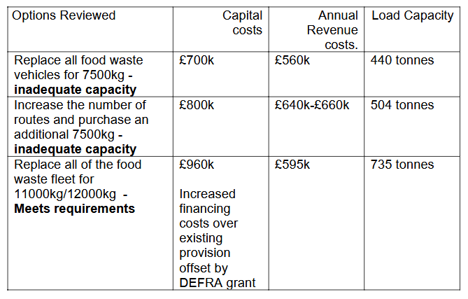

**BDC’s Annual Plan Approved at Cabinet**

**The Annual Plan 2025/26 proposes the Council’s activities and performance measures to support the second year of delivering the Corporate Strategy 2024-2028. The activities and performance measures are aligned to each Corporate Strategy themes as follows:**

**• Communities**

**• Prosperity**

**• Environment**

**The Annual Plan 2025/26 includes actions to continue delivering against the Council’s Fit for the Future programme which will be reviewed to align with work to support Devolution and Local Government Reorganisation. The Plan also provides the framework for managing the delivery of the activities against the priorities by regularly reviewing progress and achievements and reporting on the progress on a quarterly basis to Cabinet.** Following the announcement that Essex has been accepted onto the Devolution priority programme, the Government has also agreed to explore local government reorganisation alongside devolution. There will be a need to re-align the transformation activity to ensure the Fit for the Future programme reflects the ongoing needs of the organisation.

Some of the key actions highlighted from the Annual Plan included:-

- Revisions to the Local Plan to ensure there was a fresh framework to enable sustainable development across the District;

- Setting a target for the delivery of 250 affordable homes over the next year;

- Developing a supported housing strategy to support people and families at risk of homelessness;

- Building more social connections through the provision of sports facilities and community centre in Witham, as well as refurbishing four more play areas across the District;

- The provision of a range of funding to boost local initiatives such as the continuation of the Councillor Grant Scheme, the Cost of Living Scheme and administering health grants;

- Sustaining the growth of the District through delivering town centre improvements in Witham and Halstead and supporting neighbourhood plans in local villages;

- Assisting with the development of the North Essex Growth Plan that would facilitate and encourage constructive engagement with the forthcoming plans for devolution in Greater Essex; and - Improving the economic wellbeing of the District’s residents by providing more successful job fairs and supporting green skill programmes.

**Cllr**. Diana Garrod

Braintree District Councillor - Bumpstead Ward